**Walmart Sales Analysis Report**

**Prepared by : Prafull Gosavi**

**Date : 11-04-2024**

**Executive Summary**

This report presents a comprehensive analysis of Walmart’s sales data over the period of 2011 to 2014. Key performance indicators, such as total sales, total profit, and sales by category and region, were analyzed to identify trends, challenges, and opportunities. The analysis revealed total profit total sales, sales by states, sales by cities etc. This report leverages visualizations created in Power BI to facilitate the understanding of complex data patterns.

**Table of Contents**

1. Introduction
2. Methodology
3. Analysis and Findings
   1. Data Overview
   2. Sum of sales by states
   3. Sum of profit by states
   4. Sum of quantity by month
   5. Sales by category
   6. Sales by city
   7. Total orders by states
4. Conclusions

**1. Introduction**

This report aims to analyze Walmart’s sales data to identify key trends, meaningful insights. Covering the period from 2011 to 2014, the analysis encompasses various aspects of sales data, including regional sales performance, product category analysis, total orders analysis, total sales analysis, sales by state analysis. also many more insights we have find out using power bi like how much sales were done in the year 2011 to 2014, then also how much profit Walmart company earn by years, also find out the total orders by month etc.

**2. Methodology**

The analysis was conducted using the power – Bi on Walmart sales dataset of year 2011 to 2014, The methodology focused on identifying patterns, finding out insights and trends relevant to Walmart’s sales. we use to import the dataset into the power-Bi and then add some extra column in it using the new measure in the power-Bi so it help us to find out more insights from the dataset. the new measure I have added like total profit, total sales, total category of the product, also total customer and a total quantity of the products.

**3. Analysis and Findings**

***3.1 Data Overview***

The dataset contains total sales transactions from Walmart across all states and cities in United State. the period of 2011 to 2014.

***3.2 Sum of Sales By State***

**Visualization 1**: clustered bar chart of sales by states.

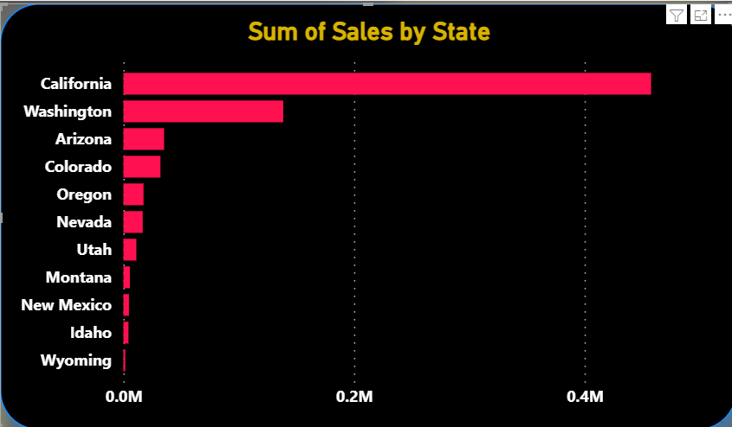

***Description:*** The California state reported the highest sales at 457k, representing 61.09% of total sales. California leads with the highest sales.

***Insight:*** The California state performance is contributed to highest sales in the united state in the year of 2011 to 2014. here we can see California contributed the highest to make the profit from the sales about 70.45% of total states profit. the total profit made by only California state is about 76K. with that Washington sales 19.90%.and Arizona with 4.86%

**3**.**3 Sum of Profit By States**

**Visualization 2**: Clustered Bar chart showing sum of profit by states.

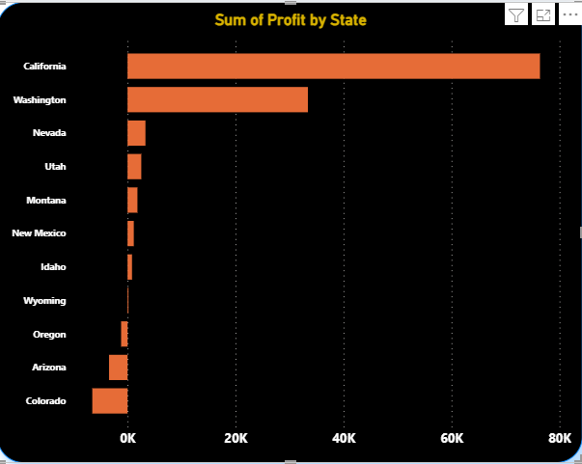

Description: This visualization showcases the profitability of each state.

Insight: Despite California having the highest sales, Washington shows the highest profitability, with a profit margin of 30.1%, followed by Nevada with 3.1% and Utah with 2.35%.and Oregon with losses-1190 of Arizona with losses of -3340 and Colorado with loss of -6527

**Visualization 3: Profit by category**

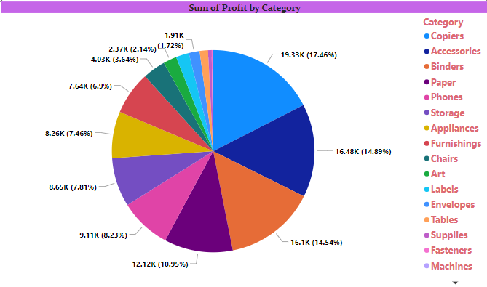

Description: The pie chart illustrates the profitability of different product categories.

Insight: the copiers exhibit the highest profit margin at 17.4%, followed by accessories with 14.48% and blinders with 14.54% and paper with 10.95%. and the lowest profit margin 1.72% of machines.

**Visualization 4: Sum of quantity by month**

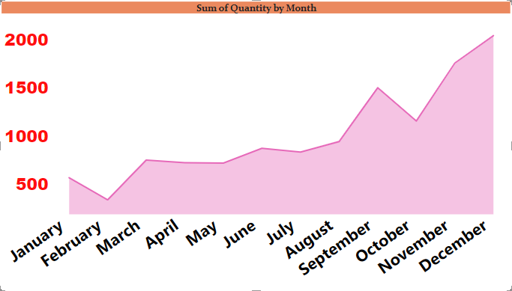

***Description:*** This stack area chart displays the total quantity of products sold each month.

***Insight:*** December witnessed the highest quantity sold, with a total of 2400 units, followed by November with 1761 units and October with 1161 units. And the February witnessed the lowest quantity sold with total of 344.

**Visualization 5: Sum of sales by category**

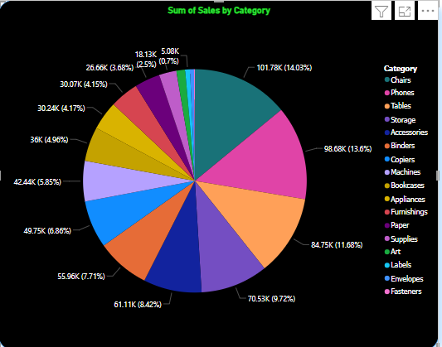

***Description:*** The bar chart depicts the total sales revenue generated by each product category.

***Insight:*** chairs contribute the most to total sales, generating 101.78K in revenue, followed by Phones with $98.68K and Tablets with 84.78K & the lowest sales by Fasteners with 5.08K.

**Visualization 6: Sum of sales by city**

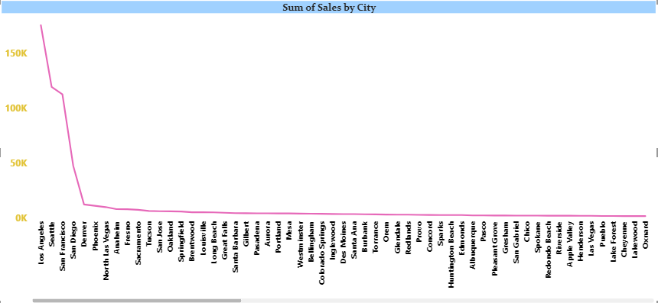

Description: This map visualization illustrates the total sales revenue by city.

Insight: los Angeles City leads with the highest sales revenue of 175K, followed by Seattle with 119K and Sun Francisco with $112K.

**Visualization 7: Total orders by states**

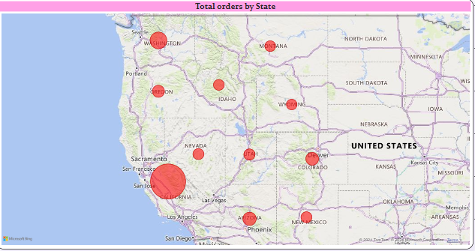

Description: This map visualization illustrates the total orders of product by states.

Insight: California City leads with the highest orders of 2001 items, followed by Washington with 506 items and Arizona with 224 and the Montana with the lowest orders of 14 items.